
___________________________________________________________________
Country View Realty and Development
5529 US 98 N Lakeland, FL 33809
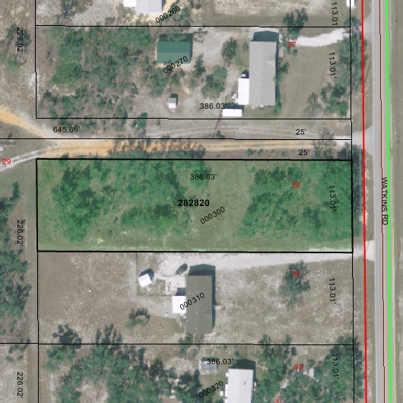
LOT INFO: BEAUTIFUL 1 ACRE LOT JUST SOUTHEAST OF HAINES CITY. HAS ABUNDANANT TREES AND IS CLOSE TO POINCIANA/KISSIMMEE. LOT HAS COUNTY WATER.

PARCEL ID: 282820-935618-000300

ADDRESS: 3000 WATKINS ROAD HAINES CITY, FL 33844

LOT SIZE: 1.0 ACRES (113 X 386)

LOT PRICE: $34,950

DIRECTIONS: FROM THE INTERSECTION OF HWY 27 AND HWY 544 GO EAST ON HWY 544 TO SECNIC HWY 17. PROCEED SOUTH TO HWY 542. TURN RIGHT ON HWY 542 AND GO 4 MILES TO WATKINS ROAD. TURN RIGHT, PROPERTY WILL BE 1 MILE ON RIGHT.

FOR MORE INFORMATION CALL:
LEE SAUNDERS RICHARD SAUNDERS
(863) 660-4803 (863) 660-1002
www.cvrdfl.com

